**IFT598: Middleware Programming & Database Security**

Arizona State University

ProjectM4A4: Creating a NoSQL Database in MongoDB Atlas

**Student**

Chih-Chieh Chang

**Professor**

Dinesh Sthapit

October 23, 2022

Test with Postman

4.1 Add a new loan

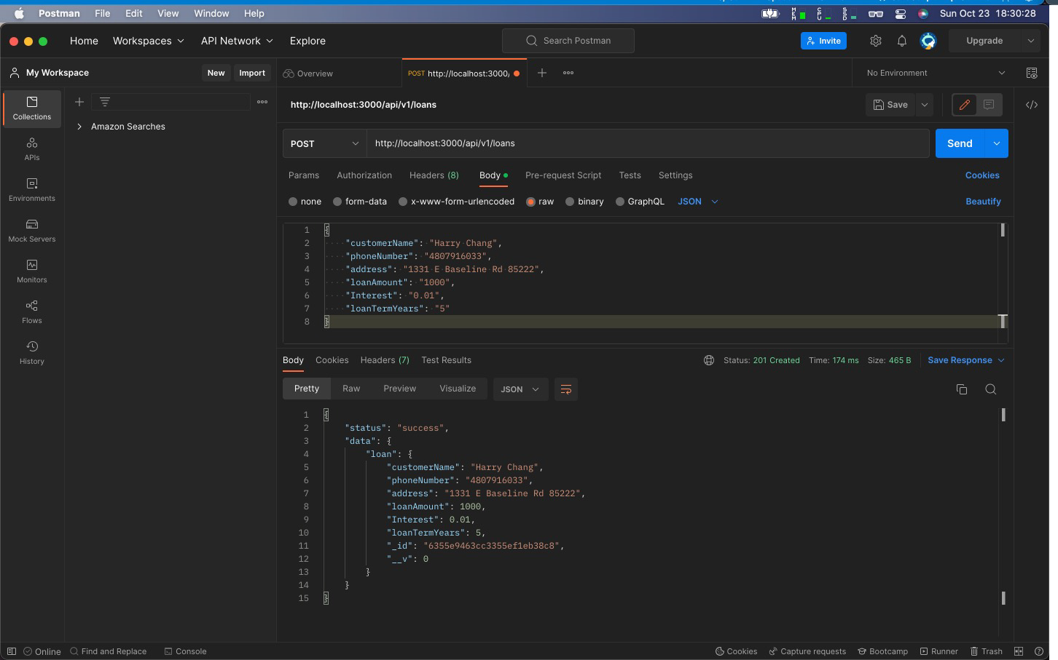

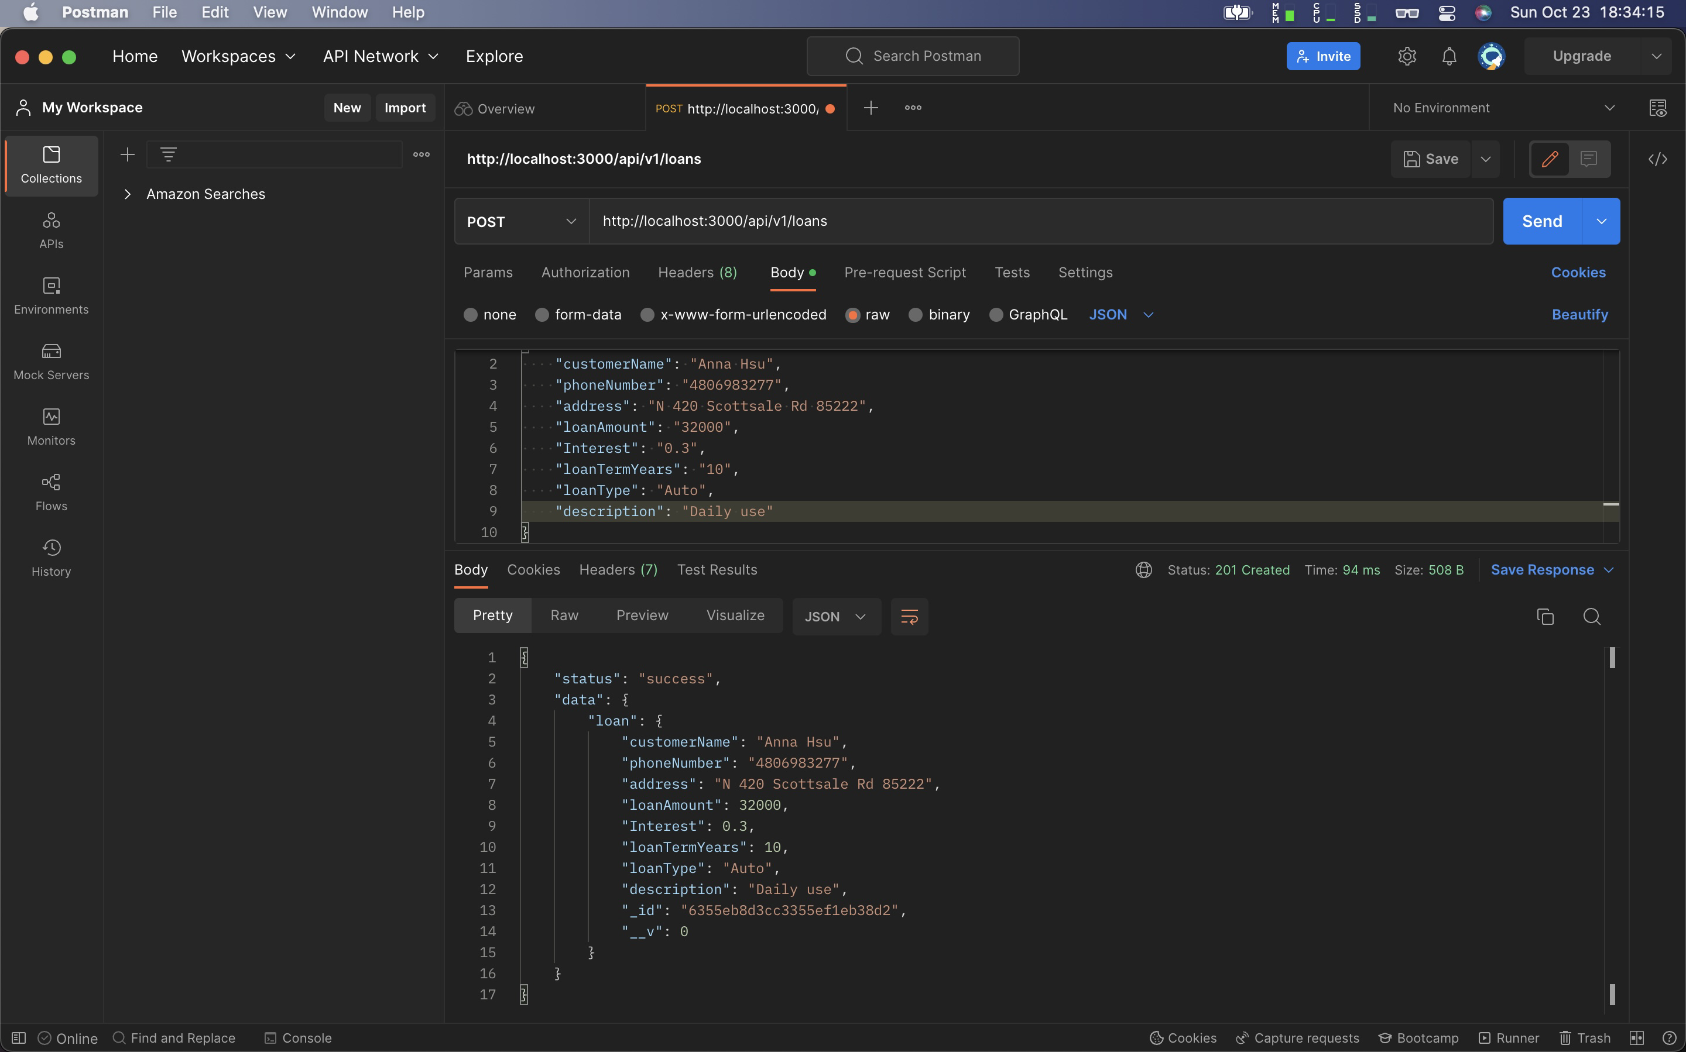

5 instance

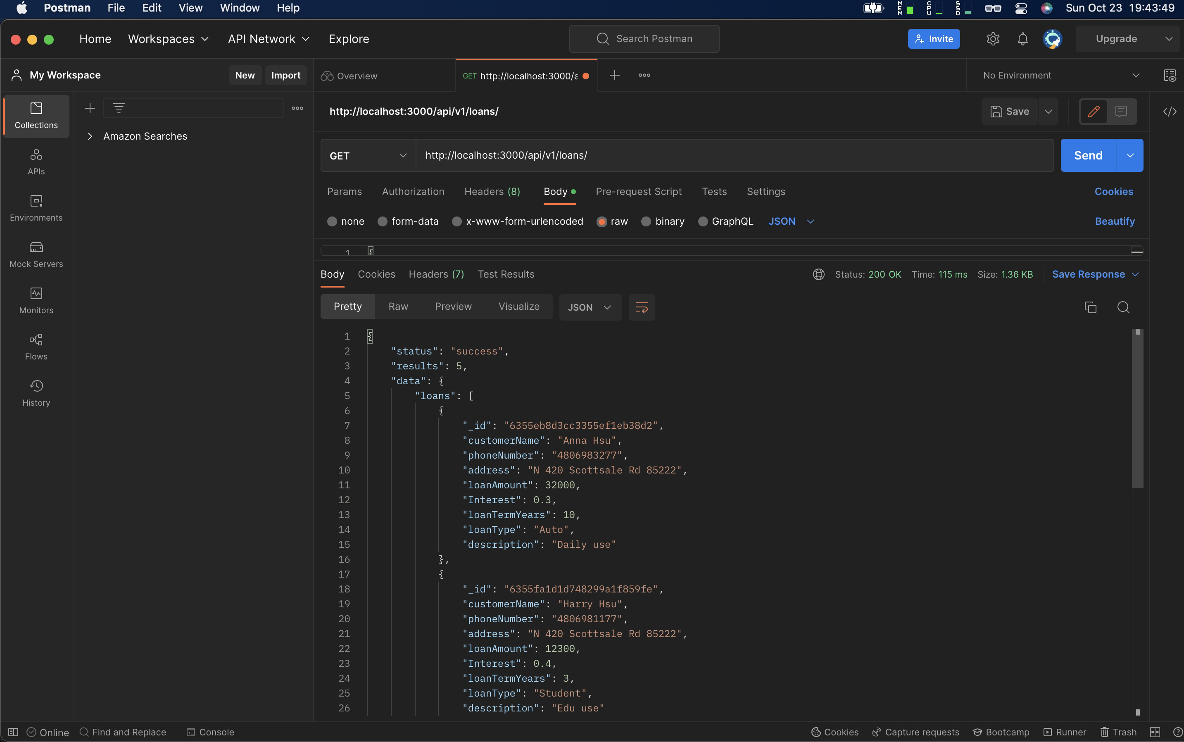

4.2 Get All Loans

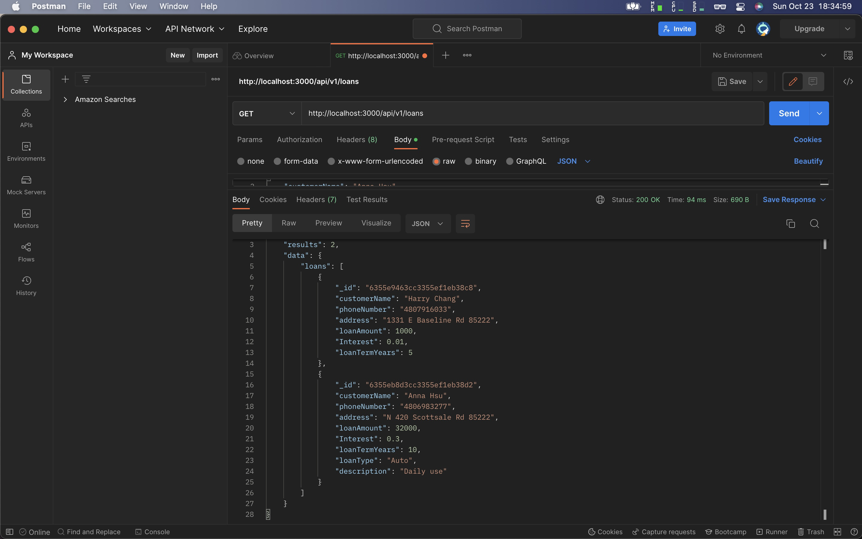

4.3 Get a Specific Loan By ID

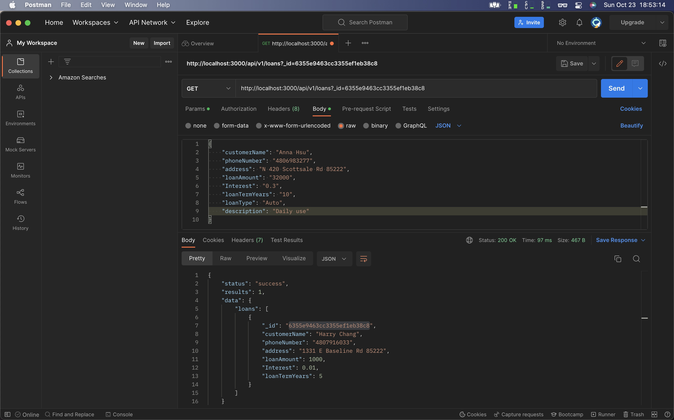

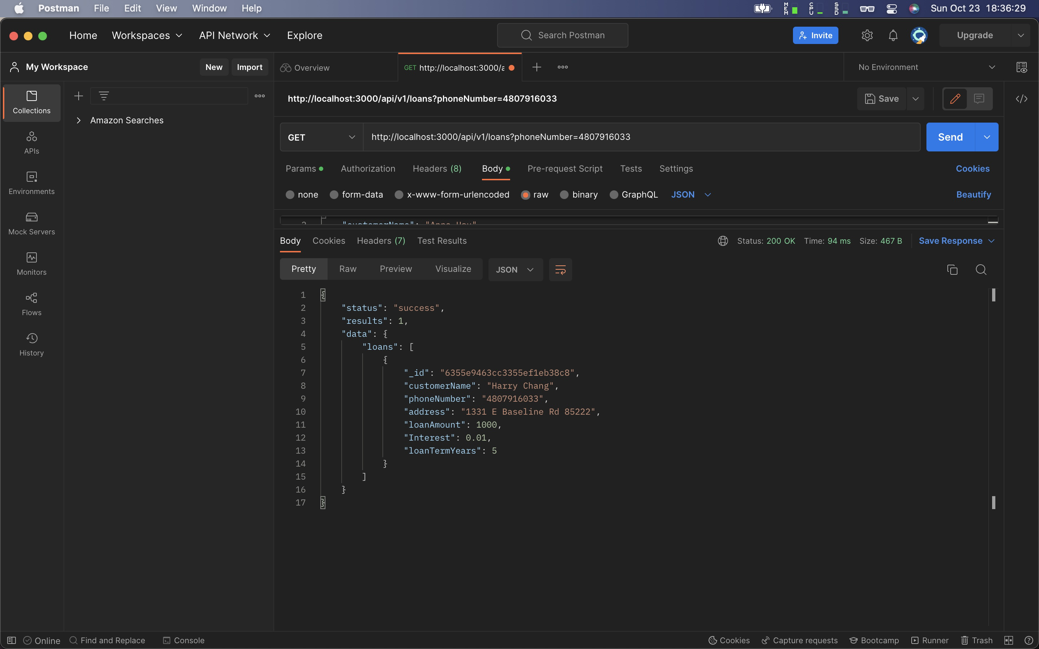

4.4 Change an Existing Loan

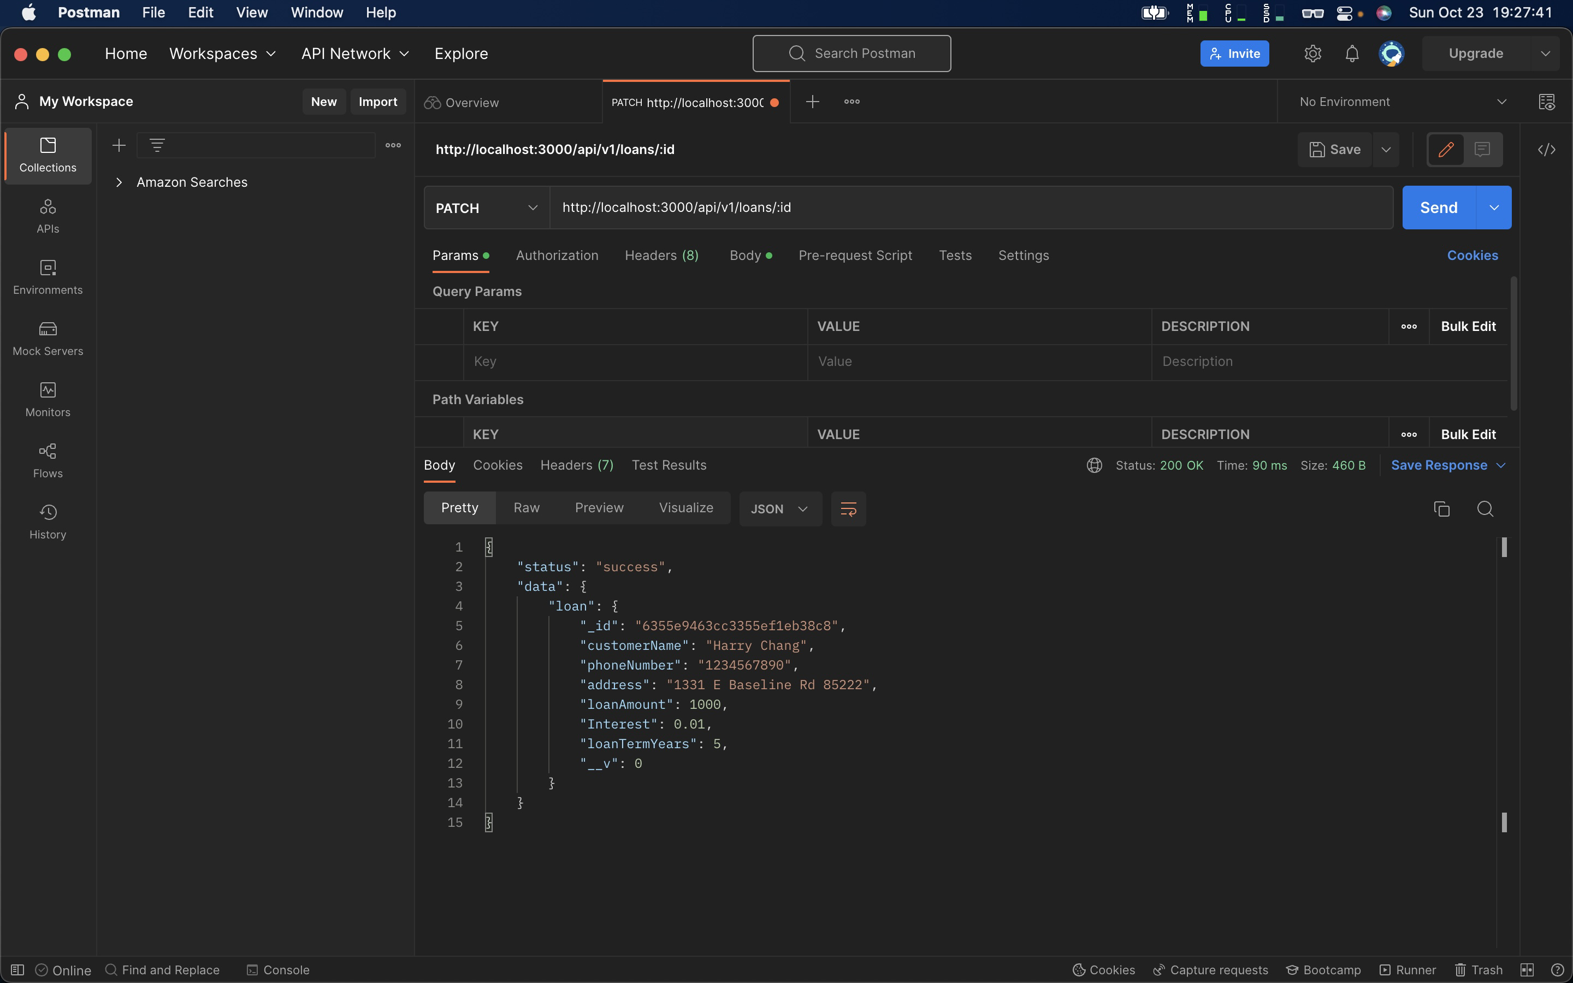

4.5 Delete a Loan

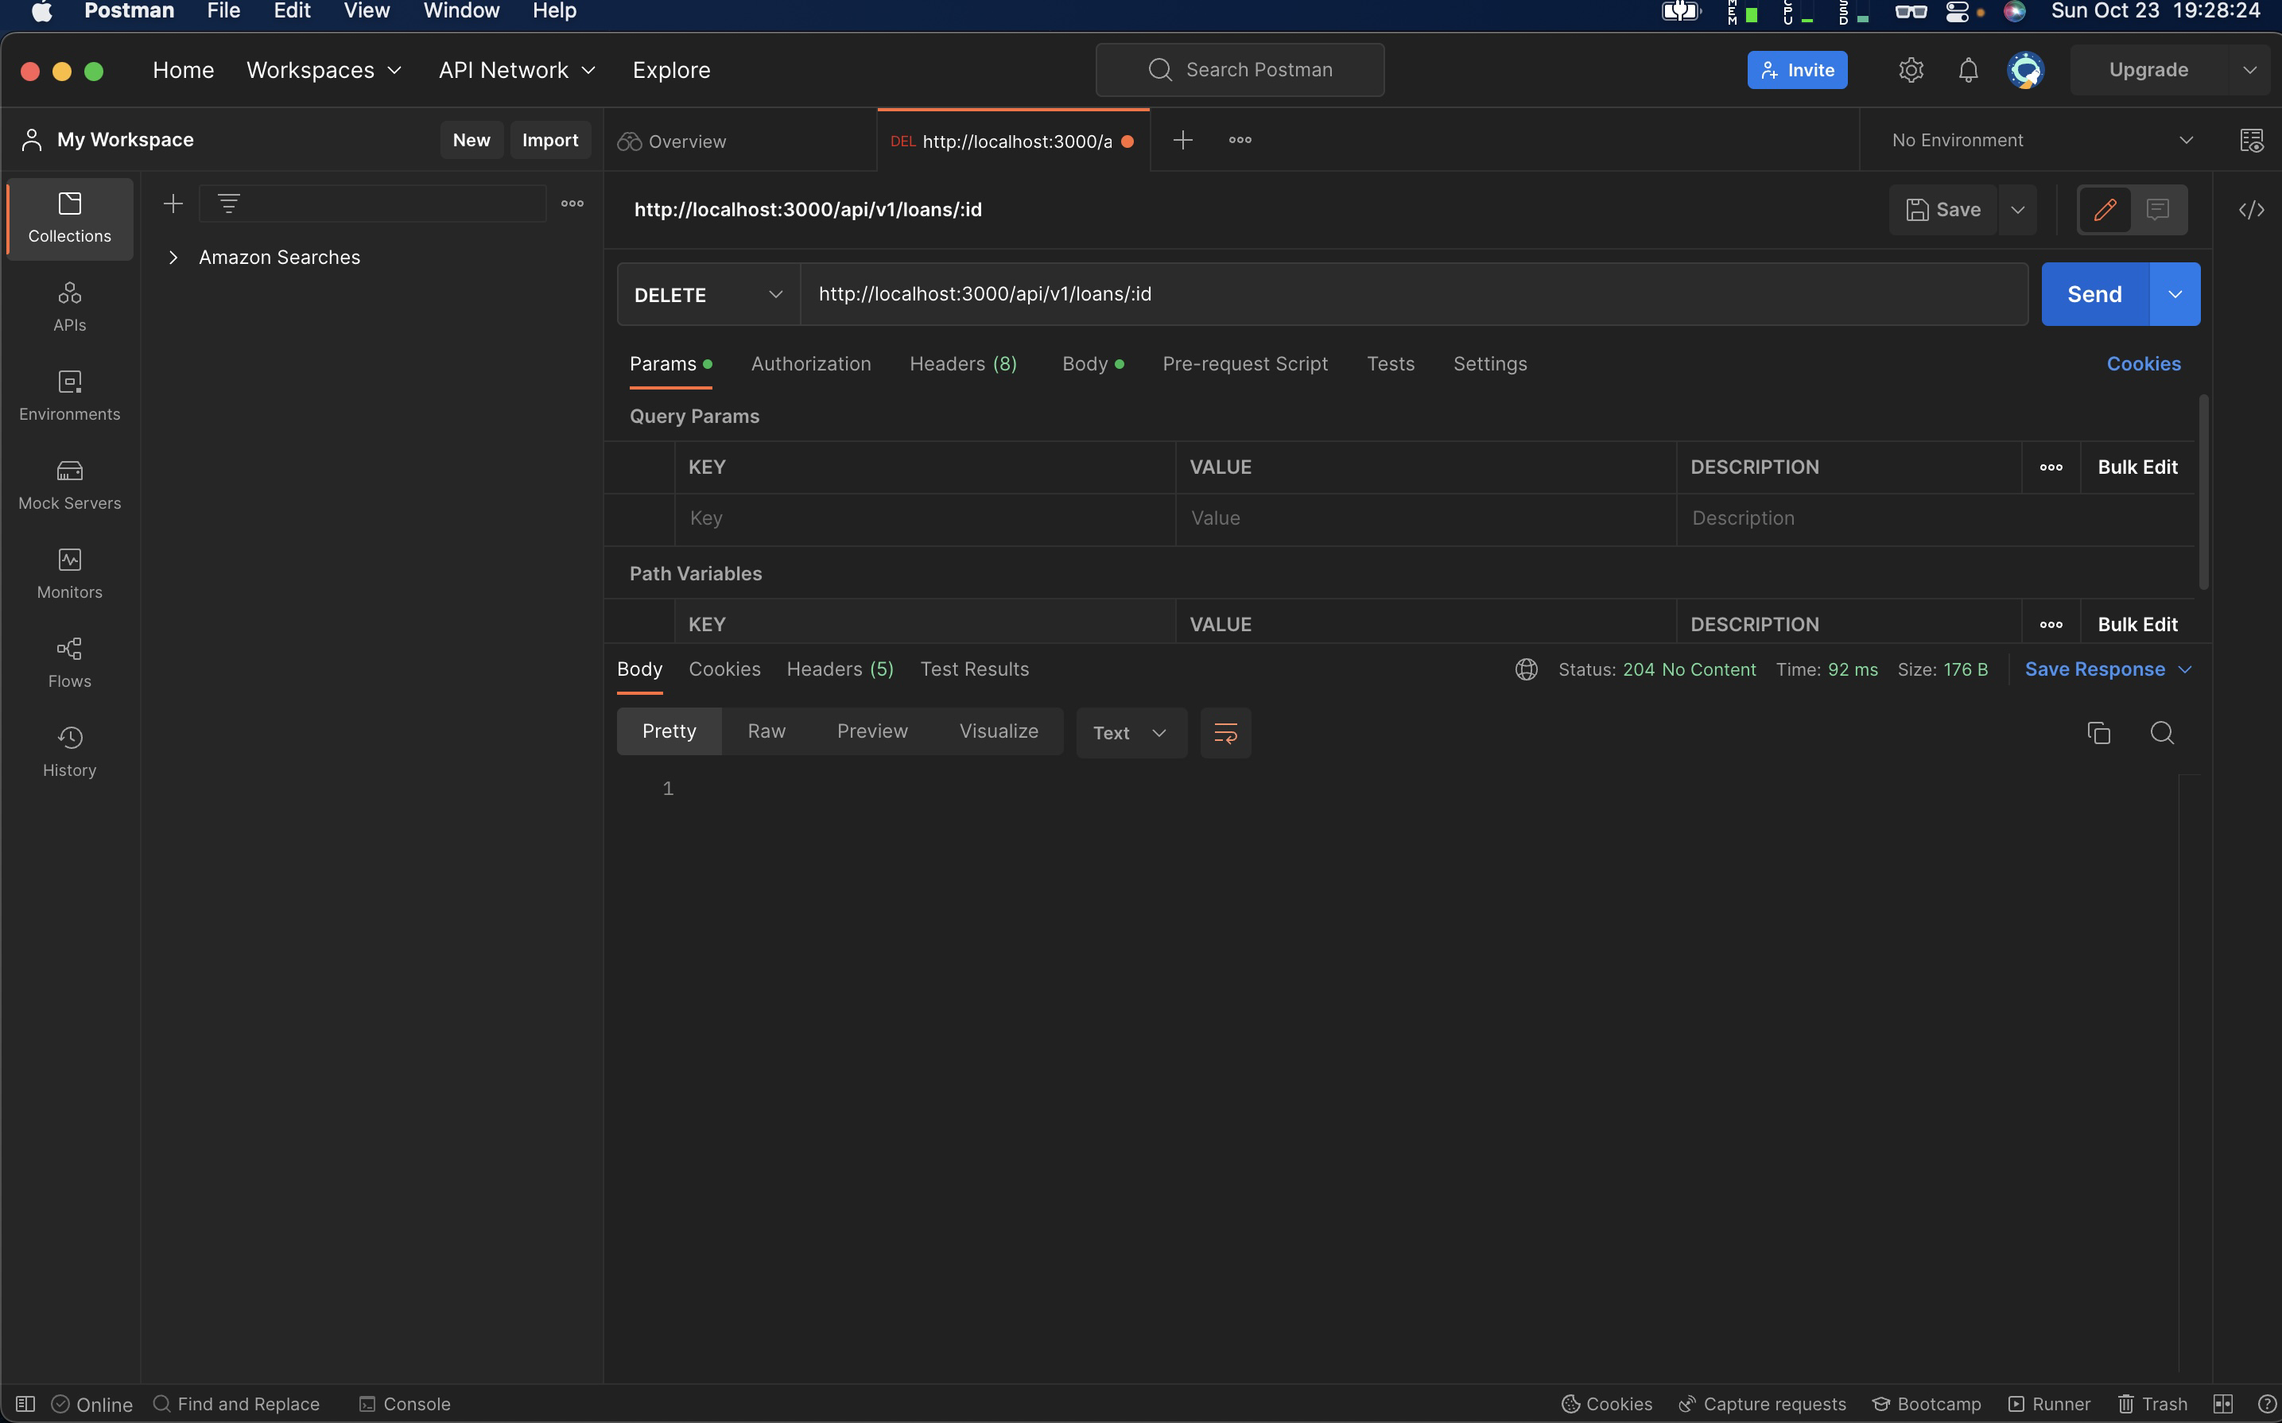

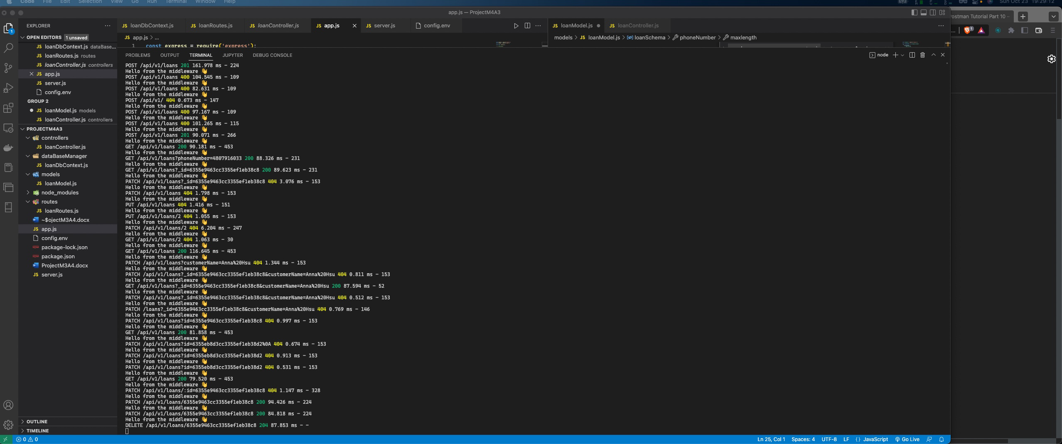

Final Result

